JINGLE BELL ROCK (or not) FINAL WEB DESIGN 1 PROJECT
Create a folder in the Projects folder and then create a Site in Dreamweaver. Save all images and files to this folder.
You will rewrite the lyrics to Jingle Bell Rock. It doesn’t have to be Christmas themed, but that’s certainly an easy option.
Jingle bell, jingle bell, jingle bell rock  Jingle bells swing and jingle bells ring  Snowing and blowing up bushels of fun  Now the jingle hop has begun  Jingle bell, jingle bell, jingle bell rock  Jingle bells chime in jingle bell time  Dancing and prancing in Jingle Bell Square  In the frosty air.  What a bright time, it's the right time  To rock the night away  Jingle bell time is a swell time  To go gliding in a one-horse sleigh  Giddy-up jingle horse, pick up your feet  Jingle around the clock  Mix and a-mingle in the jingling feet  That's the jingle bell,  That's the jingle bell,  That's the jingle bell rock | Your Lyrics….

PLANNING/PREP
- Create a “blank” version of your page (a template if you will). Save it as blank.html (Save As to create pages)
- All pages must have the same layout and utilize a DIV box in the middle of the page that includes a PNG heading banner. Animation is OPTIONAL on the banner. The banner must have transparent areas (cannot just be a rectangle) with a unique shape, images pulled off their backgrounds, and text with the title of your story.
- The DIV should be a solid color; the BODY background should be a tiled, relevant image (not a full size picture).
- First page is index.html and will include an Imagemap that links to all of the pages of the story. The imagemap must include words (added in Fireworks) on top of an image (can have a white bg). It should also include a table that is styled to have shading that lists you as the author and designer, project date, and credits any sources of images you use. Google is not the source; if you Google an image, you must “Visit page” and find out what page that came from. That should link back to those pages as hyperlinks. A bulleted list might be a nice touch.
- Then, you will create page1.html through page5.html that will be each paragraph of your story. Include artwork on each page. Artwork must NOT include any white backgrounds; please use clipart with transparent backgrounds. And, you must take a still clipart and animate it on at least ONE page. You can do more than that if time permits.
- Each page must have a back, next, and Home button that hyperlinks to the appropriate places. You should NOT have a back or home button on the homepage or a next button on the last page, however! Use this site to find buttons, free and easy. Just add words as needed in Fireworks. http://www.freebuttons.com/ Be sure buttons (when hyperlinked) do not have an ugly border around them.
My Example blank.html page (I can then remove the buttons I don’t need on the different pages, etc.)
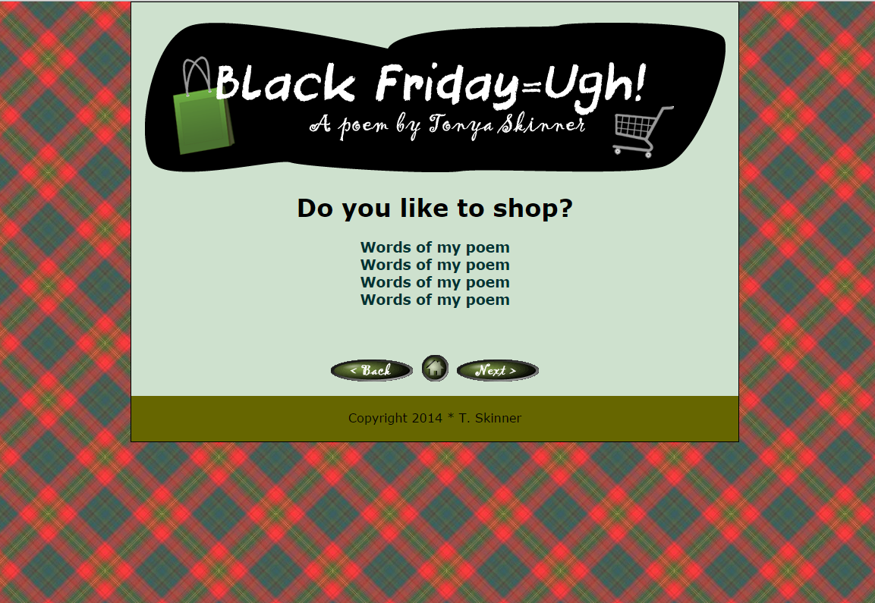
My Example index.html
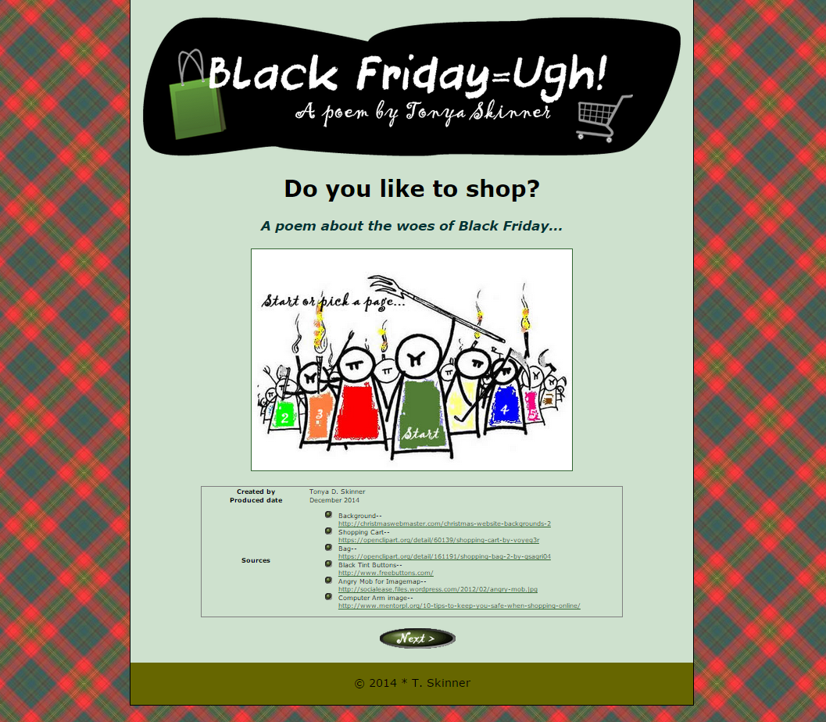

Sketch Out Your Plan….
NOTES

Index.html | page1.html | page2.html
page3.html | page4.html | page5.html

SCORING GUIDE FOR WEB DESIGN FINAL PROJECT—Jingle Bell Rock or Not name:_________________________________________
**Be sure to create a site folder for this project. You will copy your Project folder to a USB drive for grading. This will NOT be graded from your U drive. Codes for the CSS page (all pages will use one CSS page) and the index.html page should be printed.**
Requirement | AWESOME | OKAY…. | NEEDS WORK!
Content –20 pts | Text of the entire “song” is used (all 5 paragraphs) and use a similar rhyming scheme. Copyright information including student name and date are included. Title bar includes title of story/song and student first name. Sources of information are credited on index in styled table. | Missing copyright information or improper title bar or rhyming convention is not apparent. | Little effort made to rewrite content for personal theme or missing title bar. Sources not credited for images.
Buttons --20 pts | Graphic buttons are used for Next, Back, and Home and are hyperlinked appropriately; at least ONE button uses a mouseover; buttons removed from pages where it doesn’t make sense (Home shouldn’t have a Home button, for example). No “hyperlinked” borders appear. | Buttons are not readable or do not match overall theme, issue with one button, missing mouseover, or hyperlinked borders show in one or more browsers. | Buttons are missing or are not hyperlinked.
Graphics –30 pts | High quality graphics are used on every page and clipart has white backgrounds removed; an imagemap is created with words added in Fireworks that link to all pages on the index page; at least one animated graphic is created in Fireworks showing motion in layers; heading banner contains irregular shape, text, and at least two images and is professional | One issue with imagemap, images, or animation but nothing distracting to the overall webpage or images do not have white backgrounds removed. | Low quality or watermarked graphics are used or no animation is included
Spelling/Grammar –10 pts | Document uses correct spelling and grammar | Document contains fewer than 3 spelling errors or has issues with capitalization | Document contains more than 3 errors with spelling, capitalization or grammar
Overall Professional Appearance  --30 pts | Site is complete (all 6 pages) with a consistent color scheme and centered DIV; background for body uses an appealing tiled pattern (not a photo). | Site is mostly complete, but contains issues with taste, colors, or structure; photo used instead of tiled background or background is distracting. | Site is incomplete
Efficient Coding and Structure  --15 pts | CSS page is printed and only one CSS page used for entire project with all pages linked to it. INDEX page is printed and coding is neat and error free. Text alternatives used on all images. | Mostly efficient coding is used with some minor errors in syntax or usage or a few typos. Missing text alternatives. | No codes printed or significant errors in coding.
Total—125 PTS X 2=
250 POINTS POSSIBLE
COMMENTS For “bonus” consideration, you may create a FAVICON for your page or create additional animations. Or, add a link to you “singing” your song on your index or ending page!! Fun!!

